August 2018 Newsletter
Le Mars Arts Center
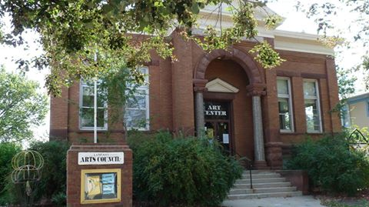

Every Week

Monday 6:30 – 8:30 PM
Oil painting with Hope Wallen
$86/month includes all supplies. Learn techniques and exercises to help you paint your own masterpiece! Pre-Registration required

Wednesday 2-4 or 6– 8
Watercolor with Jean Weiner
$20 each week. Fun and easy! Just show up and let Jean help you create your first watercolor masterpiece!

We’re at the Farmer’s Market
Every Saturday 9 – Noon
Behind Cork It!

Old Time Country and Bluegrass music performers
August 27 – Sept 2, noon – 1
Listen to a song and have a sandwich over the lunch hour! Watch our facebook page for each days performers!

Summer Hours
Wednesday – Friday
1:00 – 5:00
Contact us to make an appointment outside of these hours! We are happy to have you come in.

200 Central Ave SE lemarsarts@frontiernet.net 712-546-7476 lemarsarts.com
To engage the mind and inspire the spirit thru the arts.
Greetings!
August already?? This summer is flying by and before you know it the kids will be back in school and we will resume a routine! We have really enjoyed our summer and will be savoring every last day until the kids are back in school!
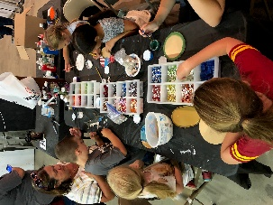
Wrap up from the Best 5 Days of Summer
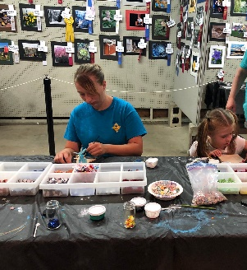
New this year for us in the open class building was an art activity! 40 kids found us on Saturday and Sunday of the fair and created fun projects! We hope to do this again next year and have it included in the fair book and schedule.
We had 219 entries in our open class art and photography this year! Thank you to all of you who brought your work in for exhibit. Jason Jauron received the Best in Show for the photography exhibit and Randi Mackey received Best in Show for the 2D and 3D art exhibit! It was wonderful seeing everyone and start thinking about your entries for next year!
One last Summer Program!
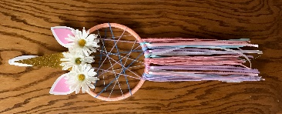
Mystical Magical Day Camp
Saturday, August 11, 10:00 – 2:00
Bring a sack lunch
$40/child going into 1st grade and up
Call to register at 546-7476 or our website at lemarsarts.com
Only a few spots remain!
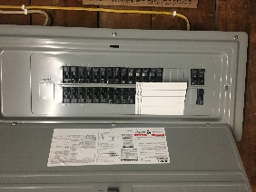
NEW and UPDATED
Art Light
I’m starting this new section to help you meet some of the people that make the Arts Center so great! This could be an instructor, a board member, an artist, a patron, a donor, a child or an adult. Each month we will feature someone!
Meet a Board Member
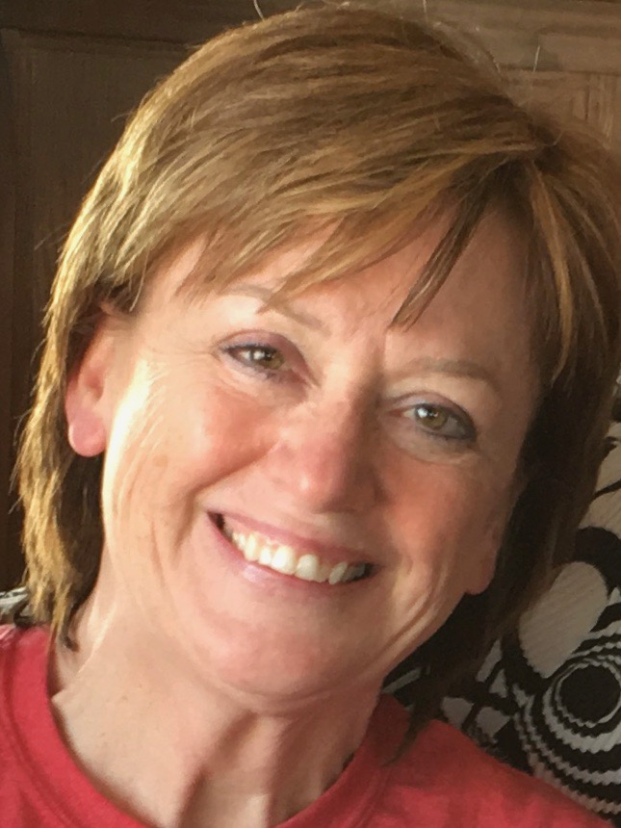
Lisa Boehm, Treasurer
Lisa has lived in Le Mars or the surrounding area, pretty much her whole life! Lisa works full time at Primebank and has been there for over 25 years. She is also the secretary to the Le mars Community Board of Education since 2005. Lisa loves to spend her spare time with her children, grandchildren and close friends. Here’s what she has to say about art!
“Whether it is singing, listening to or playing music, painting, gardening, telling stories, or enjoying sunrises or sunsets, art is a part of us……Art can show what words can’t.” Lisa invites each and every one of you to come to the Arts Center and experience the Art in you!
Lisa has been on our board for 2 years – Thank you, Lisa!
While we were busy at the fair, our building had its electrical panel updated, a new air conditioner installed AND a new furnace and duct work to better heat the lower level!!! Thanks to the City of LeMars for their help in this project financially! And thanks to the Langels that helped us with fulfilling our needs in a budget! They have been very generous to us in a number of projects! We are so excited that our kids will be warm this winter during Mommy and Me and our after school Art Club! We can’t wait to try it out! We are all very excited about this update! Over the next couple of weeks, outlets will be added and updated too! This will help us to better serve all of our patrons everywhere in the building!
So Much More to Come!
We have been very blessed this year to receive 3 grants already! We received the Capacity Building Grant from the Iowa Department of Cultural Affairs! This grant will be sending Judy and Shelby to a Convention for all kinds of training! They will learn all kinds of new things to offer in our studio for all ages and abilities! We will be learning new techniques, new offerings, business and technical help and so much more! We are really looking forward to offering the community more on a walk in basis, corporate events and parties! Watch for more information on our website and facebook page and make sure you tell your friends to like our page and follow us, too!

We also received some funding from United Way to help us continue our Mommy and Me program which we have seen such amazing results from in the past year! We are so excited to continue that again this fall. We also received United Way funds to support art programs for seniors and adults with disabilities! We are really looking forward to working more with all of these groups in our own community!

And last, but certainly not least, we received a grant from the Gilchrist Foundation to help with much needed renovations to the facility! Look for changes and updates to the inside of the building in order to better accommodate all that we have to offer and take us into future growth!

Old Time Country and Bluegrass Festival performers will be our guests again over the lunch hour August 27 – September 2! Mark your calendars and plan to come listen to just a taste of what to expect this year at their 43rd Annual Festival at the fairgrounds! This is our 3rd consecutive year to offer this at no charge! Line up to be announced, but every single one of them is amazing! Don’t miss it! Noon – 1 each day.

